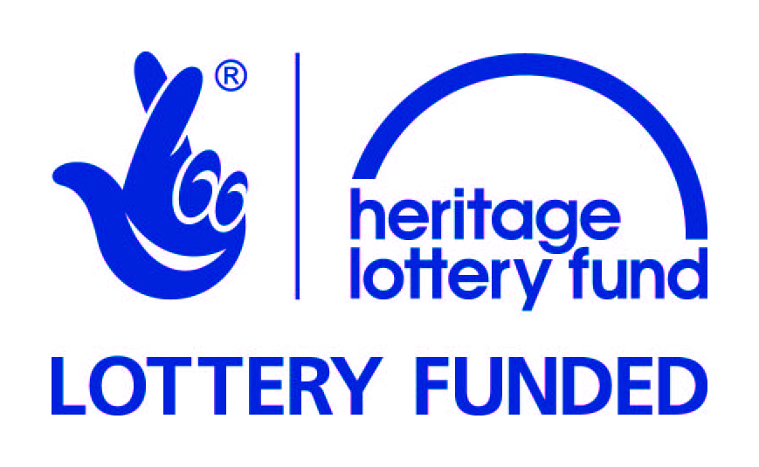
South London Botanical Institute, 323 Norwood Rd,
London, SE24 9AQ 020 8674 5787
info@slbi.org.uk www.slbi.org.uk
or
GIFT MEMBERSHIP
Gift an Event
Why not share your love of the world of plants by giving Gift Membership or a Booking one of our Events for your friends or relatives?
Membership: will introduce them to “the hidden gem of South London” that is the South London Botanical Institute, with advance notice of the programme of EVENTS: lectures, workshops, field trips and botanical surveys, discounts, special events and our colour Gazette.
Event Booking: gives someone a chance to try their hand at something inspiring and educational. Or give both and get a reduced event rate!
Complete the NEW MEMBER/EVENT form below and return to us and we will send a gift card to them (or you, if you want to gift it yourself, see below), together with the latest Programme, the Seed List (members only) and our Brochure.
Please give your cheque for £18.00 for one membership and don’t forget to give us your name and contact details. Please sign gift aid form on the back if appropriate (Membership only).
NEW MEMBER DETAILS or NAME OF ATTENDEE for EVENT BOOKING DETAILS (delete as appropriate)
Title……..First name ………………………… Surname ......................................…….
Address………………………………………………………………………………………………………
……………………………………………………………………...Postcode ..………………………….
Tel. ………………………………………… Email……………………………………………………..
Complete the Name of the Event below, add correct payment and return to us and we will send a gift card to either you or direct to them
(*delete as appropriate below)
NAME OF EVENT
…………………………………………………………………………………………………….
……………………………………………………………………………………………………..
Your details (present giver)
Name ………………………………………………………… tel. ……………………………………….
Email …………..…………………………………………………………………………………………………
I enclose a £/cheque for ……….. Signed ……………………………………………………………..
*Card and Gift to Giver/Receiver (delete as appropriate)

SOUTH LONDON BOTANICAL INSTITUTE (Reg. Charity 214251)
CHARITY GIFT AID DECLARATION FORM
Boost your donation by 25p of Gift Aid for every £1 you donate

Gift Aid is reclaimed by the charity from the tax you pay for the current tax year. Your address is needed to identify you as a current UK taxpayer.

In order to Gift Aid your donation you must tick the box below
I want to Gift Aid my donation of £……………. and any donations I make in the future or have made in the past 4 years to South London Botanical Institute.

I am a UK taxpayer and understand that if I pay less Income Tax and/or Capital Gains Tax than the amount of Gift Aid claimed on all my donations in that tax year it is my responsibility to pay any difference to HM Revenue & Customs.
My details

Title…………First name or initials……………………………………
Surname…………………………………………
Full home address……………………………………………………………………
…………………………………………………………………………………………
Postcode……………………………… Date…………………………
Email address……………………………………………………………

Please notify the charity if:
• want to cancel this declaration
• change your name or home address
• no longer pay sufficient tax on your income and/or capital gains and wish to withdraw from the Gift Aid scheme.
If you pay Income Tax at the higher or additional rate and want to receive the additional tax relief due to you, you must include all your Gift Aid donations on your Self-Assessment tax return or ask HM Revenue and Customs to adjust your tax code.

Company Limited by Guarantee No 116643

